**CHAPTER ONE**

**INTRODUCTION**

**1.1 Background of the Study**

The rapid spread of the internet is well known, with its size and power making it today’s dominant software development platform. Present technology has gone beyond client-server applications, and new forms of software products are transforming people’s individual work, organizations, and society and Nigeria is not exempted from this technological change.

Nigeria is a growing tourist destination, there has been a good rise in the number of hotels and resorts in Nigeria and the tourist sector is broadening, thus the rapid development and commercialization of Information and Communication Technologies (ICTs) for the travel and tourism industry has prompted hotels and other enterprises in this sector to increasingly adopt these technologies. The ICT based products and processes help the hotels to enhance their operating efficiencies, improve the service experience as well as provide a means to access markets on a global basis. The current increase in tourism and rise of foreign investors around the world has made a need for online hotel reservation to come to play as tourists can book a hotel room online even from the airport. The hotel industry has the function of providing hospitality services to customers. These customers can be travelers, foreigners, businessmen, tourists, visitors, etc.

The goal of every hotel is to sell more rooms and make profit, yet without an online reservation system they are forced to remain local while rely on phone calls and walk-ins only to make reservation. An online reservation system is now a necessity for hotels as it creates a system that can extend and compete globally, allowing guests to make reservations by selecting preferred room, scheduling dates and length of stay and make payment all in on one platform and at the same time. Online Hotel Reservation System is efficient, yet it is easy and uncomplicated to use. Online hotel reservation provides a hassle-free management of bookings as the reservation system is computerized as it works all the time, affording potential visitors book available rooms anytime and anywhere. It enables one to check available inventory (as it provides an instant ‘picture’ of which rooms are available for reservation) and complete an online reservation with the whole process being less time consuming. It reduces the dependability on Online Travel Agency (OTA) and other travel agents as clients are available to 24x7 reservations and get queries resolved quickly by directly communicating with hotels rather than waiting to get confirmation for their bookings. This would increase the efficiency of staffs as they will not be tied to a phone waiting for guest calls and also reduce cost as it will eliminate email exchanges between guests and reservation personnel. Online reservation reduces workload for staff and optimizes customer service.

Beyond having any great and functional software, it requires the right technology, platform and environment to get the most out of it, especially in terms of adequacy and efficiency. Therefore, having an online reservation system is one thing, but having an effective online reservation system is another, and this is the need for a cloud based hotel reservation system. Cloud is a cluster of Linux servers accessed through the internet. Cloud computing is thus the on-demand availability of [computer](https://en.wikipedia.org/wiki/Computer) [system resources](https://en.wikipedia.org/wiki/System_resource), especially [data storage](https://en.wikipedia.org/wiki/Data_storage) and [computing power](https://en.wikipedia.org/wiki/Computing_power), without direct active management by the user. Cloud technology is a highly scalable and flexible infrastructure that enables developers to build, test and deploy apps. Microsoft defined cloud computing as “the delivery of computing services—including servers, storage, databases, networking, software, analytics, and intelligence—over the Internet (“the cloud”) to offer faster innovation, flexible resources, and economies of scale”.

Cloud is a significant technological development that is being rapidly adopted in this technological age. It is reliable as it provides high uptime and availability, as the system would be virtually using the resources of multiple servers such that if one server goes offline, the system is automatically transferred to another server with zero downtime. Cloud computing also makes data backups and disaster recovery easier as data is mirrored at multiple redundant sites on the cloud provider’s network.

Cloud computing eliminates the capital expense of buying hardware and software and setting on-site datacenters i.e. racks of servers thus providing greater return on investment as you pay only for the resources that are used by the system. It also has the ability to scale server resources on demand and hence the system would never go offline unlike deploying the system to a physical server in which when it has technical issues, the system would automatically go down. The cloud also affords vast amount of computing resources such as speed and performance as it accommodates easier load balancing between multiple server environments, thereby putting less strain on a single server’s resources. Also, providers of cloud services regularly upgrade their resources to be very efficient thus reducing network latency.

The cloud providers offer broad set of policies and technologies and control that strengthen the security of the system thus protecting the data and infrastructure from potential threats. This means since the system would have an integrated payment system, the user’s debit card details and other sensitive information of the user is secured from intruders.

**1.2 Problem Statement**

The current system is manual, slow and time consuming and it is very difficult for customers to book through an agent as they would have to await a confirmation for their reservation. As pointed by Polo (2013), “Guests will have to wait for confirmation within 24 hours after their booking”. Some other problems that may occur are: a customer getting to a hotel and discovers that there are no rooms available for reservation hence they are constrained in trying to get a room to pass the night; as the usual practice is to look for a hotel when you have arrived in a particular location, walk in and find out whether there is a vacant room. In the case that there is no vacant room, a customer has to move to the next closest hotel (which could be long distance apart) to make the same enquiry once more. As explained by Gabriel “Visitors might have to move around sometimes very late in the night in search of a hotel, exposing themselves to potential threats that might be lurking around only to discover that fully the rooms as also fully booked or perhaps the available room does not suit the taste of the customer

A guest checking into a hotel room that is either too expensive or too unbefitting for his/her personality; customers having little or no information about the hotels within their vicinity; prolonged delay by the receptionist in retrieving certain information about any particular guest that checked into the hotel whenever such information is demanded; the foul play that sometimes occurs when information about the guest that checked into a hotel are not officially documented by the receptionist etc. Attendants are quick to serve those who walk in rather than those who may get access to them on phone to book a room hence there is a tendency for your reservation not to be entered. Also, return on investment would be reduced as online travel agents would have a share in the price to be paid in by customers, this would reduce the hotel’s income.

**1.3 Aim and Objectives**

The aim of this study is to automate the process of hotel reservation with minimal downtime.

This would be achieved by the following objectives:

* To design and develop a highly scalable online hotel reservation system, with secured features, high uptime, scalability and availability, improved performance and decrease in load times.
* To implement the system using the waterfall model which would curb the manual method of hotel reservation giving room to 24/7 hotel reservation which in turn yields better revenue.

**1.4 Scope and Limitation of the Study**

The study covers the development of a cloud based online hotel reservation system which would facilitate online reservation; online display of the picture of the available rooms and other room features to give customers a view of the whole room from every angle alongside the room descriptions, room features to enable customers have a glance of the rooms to be reserved to meet their taste alongside the room prices, keep customers’ reservation records, room management, manage room reservations, add administrative users, secured payment system using an Application Programming Interface (API), automatically generate and send a mail to customer’s provided email containing reservation details, check-in and check-out system for customers using an automatically generated ID: a combination of alphabets and the current timestamp of every reservation. However it is limited as the system would not support rescheduling of reservation as payment is made alongside reservation.

**CHAPTER TWO**

**LITERATURE REVIEW**

Several researches have been directed towards the development of an efficient hotel reservation system. Some of the research carried out and the writer’s view concerning the development on an online hotel reservation are as follows:

Over the years, the need for an online hotel reservation has been on the increase most especially in this technological age. The Hotel Industry like any other business opens up socio-economic opportunities for both owner and customer. It has the function of providing hospitality services to customers (Richard, Akwasi & Emmanuel, 2014). This shows that online hotel reservations systems are increasing in importance and greatly facilitate cross border consumer activities.

The vast growth of the tourism and technological growth has led to the rapid increase in hotel industries. The hotel industry is a fast growing sector which poses great benefit.

However, hotels which desire to remain in business and grow its populace and revenue must make their offers and services readily available to potential customers by providing such services on a global scale. Gates (2019) stated that “any business that is not online would soon be out of business”. The customer base is every business main concern. This is very important as it is also supported by Franco and Bulomine (2016) who mentioned that businesses must increase their online presence so as to gain full mastery of their products and services amongst competitors within the same field of operations. This would make their services available anytime, anywhere and thus affording potential online customers to search and make reservations right from where they are; and as stated by Kendall and Kendall (2019), there are many rewards to mounting an application on the Web: (1) increasing awareness of the availability (2) the possibility of 24-hour access for cases; (3) standardizing the design of the interface; and (4) creating a system that can extend globally rather that remain local, then searching people in remote locations without worry of the time zone in which they are located.

Online hotel reservations are becoming a very popular method for reserving hotel rooms. Travelers can make room reservations from home by using an online security to protect their privacy and financial information and by using several online travel agents to compare prices and facilities at different hotels (Glenda and Mischelle, 2013).

The need for a stable and secured online resource is of great importance hence the need for implementing a system on the cloud. Many organizations want to move their existing legacy application to the cloud environment because they are facing some problems in adopting new technologies, platforms, and standards. (Shrikant, 2014)

Rocha and Vazquez (2014) depicts that “there are several benefits that brings cloud implementation and several competitive opportunities for organizations that use them”. Some of these benefits include cost, competitiveness, availability, scalability etc.

Cloud migration can reduce both capital expense and operating expense costs because resources are only acquired when needed and are only paid for when used. In cloud computing environment resources are managed by third party, so they are responsible for resource maintenance and upgrade (Shrikant, 2014).

Some one listed the importance of cloud

**2.2 Hotel Reservation Systems**

A hotel reservation system is a computerized system that stores and distributes information of a hotel, resort or other lodging facilities (www.mindspeakit.com). It offers assistance to hoteliers to manage all of their online marketing and sales where they can upload their rates and service availabilities to be seen by sales channels (www.mindspeakit.com). The lists of main modules that are present in a hotel reservation system are: Content, Information stored and reporting.

Content consists of Reservations, Profiles, Rate and Inventory Control, Administration, Global Distribution Interface, Web-based Interface. Information commonly stored consists of room details (room types, room image, room rate), conditions (room status, minimum length of stay, maximum length of stay, closed to arrival etc.), room inventories, generic hotel information (address, phone number, fax number) and Reservation information. The hotel reservation reporting module provides a number of standard reports. System reports may be generated automatically. It includes expected arrivals, reservations, Total Booking Activity and Stay Activity.

**CHAPTER THREE**

**SYSTEM ANALYSIS AND DESIGN**

**3.1 Research Methodology**

Research methodology is a systematic programming approach of a well-defined procedure that should be followed in carrying out a thorough research work. It is a system of methods that is used to plan, structure and control the process of developing an information system.

**3.2 System Analysis**

System analysis is the process of collecting and interpreting facts, identifying the problems, and decomposition of a system into its components. System analysis is conducted for the purpose of studying a system or its parts in order to identify its objectives. It is a problem solving technique that improves the system and ensures that all the components of the system work efficiently to accomplish their purpose. Analysis specifies what the system should do therefore it helps to decide a roadmap towards the software development. It includes understanding software product limitations, learning system related problems or changes to be done in existing systems, identifying and addressing the impact of project on organization and personnel etc.

The current system was studied and analyzed to bring to light its weaknesses and to obtain adequate information on how the system should operate. It was thus discovered that the existing manual system made bookings more difficult and time consuming because they were slower and less organized. They were time consuming because potential guests have to make queries in various accommodation facilities to gather information about rates, amenities and services to have as many options to choose from. The current manual system needs to be made more efficient by developing an online resource for its activities as this would improve organization’s efficiency and produce a high return on investment.

**3.3 System Design**

**System design** is the process of designing the elements of a system such as the architecture, modules and components, the different interfaces of those components and the data that goes through that system. The purpose of system design is to provide sufficient detailed data and information about the system and its system elements to enable the implementation consistent with architectural entities as defined in models and views of the system architecture.

The Waterfall Model was implored as it involves breaking down the requirements/problems, analyzing the system, creating functional code or solution, testing, implementing and software operation and maintenance.

The waterfall model is a breakdown of project activities into linear [sequential](https://en.wikipedia.org/wiki/Sequence) phases, where each phase depends on the deliverables of the previous one and corresponds to a specialization of tasks. It comprises of the following phases:

* Requirements gathering
* System Analysis
* Software Design
* Coding
* Testing
* Implementation

Requirements Gathering

System Analysis

System Design

Coding

Testing

Implementation

**Figure 1: Waterfall Model**

**3.3.1 Requirement Gathering**

Requirements are the high-level descriptions about a particular system services, constraint or to a detailed specification that are generated during the requirements gathering process.

Here, discussion with various stakeholders was made concerning the development of the software to bring out as much requirements as possible. Requirements (user, system and functional) were obtained from the following sources:

1. **Primary Source:** the primary source of information – which comprise of real-time data – employed for the purpose of this research was basically interview and observation.
2. **Interview:** Interview is a common method of data collection in qualitative research to explore the perspectives of respondents on a particular idea, program, or situation.
3. **Observation:** Observation, as the name implies, is a way of collecting data through observing.
4. **Secondary Source:** Here, data was obtained from published materials such as journals, magazines etc. and the internet.

**Types of Requirements**

1. **User Requirements:** This is a detailed description in natural language along with diagrams of the services the system provides and its operational constraints. It is usually development by end users.
2. **System Requirements:** It is a structured document detailing the descriptions of the system’s functions, services and operational constraints.
3. **Functional Requirements:** It describes the services of the system, how the system should react to particular inputs and how the system should behave in definite situations.
4. **Nonfunctional requirements:** It describes the attributes of the system.
5. **Domain Requirements:** These are requirements that arise from the domain of the application and that reflect characteristics of that domain.

**3.3.2 System Analysis**

It is a process of collecting and interpreting facts, identifying the problems and decomposition of a system into its components. Therefore, at this phase, the current system related problems were studied and examined to bring out the necessary requirements for the software to be developed.

**3.3.3 Software Design**

At this phase, the whole knowledge of requirements and analysis are brought on deck for the design of the software product. The inputs from users and information gathered in requirement gathering phase are the inputs in this phase. The output of this phase comes in the form of two designs; logical design, and physical design.

**3.3.4 Coding**

This step involves writing the program code to develop an error-free executable program efficiently. It is also known as the programming phase. This project therefore employs the following technologies:

* **Frontend:** The frontend, also known as the client side of a website is the part that users interact with. It comprises of everything that a user sees when navigating around the Internet, from fonts and colors to dropdown menus and sliders. It is a combination of HTML, CSS, and JavaScript being controlled by your computer’s browser.

The frontend of the system was built using Hypertext Markup Language, HTML and styled using Cascading Style Sheet, CSS. The frontend runs a framework, Bootstrap to promote software responsiveness while web interactivity was added using JavaScript.

* **Backend:** The back end, also known as the server side, of a website consists of a server, an application, and a database. Hypertext Pre-processor PHP, a server side programming language is the technology used to develop the server side.

PHP is a server side programming language therefore it must run on a server. PHP was run locally on the XAMPP server which is an apparent acronym for (Apache, MariaDB, PHP, Perl).

* **Database**: Database is a collection of related data and data is a collection of facts and figures that can be processed to produce information. A database management system stores data in such a way that it becomes easier to retrieve, manipulate, and produce information. Since, the system will handle a large volume of data; it requires a large storage in a form of database. For this purpose, MySQL, a relational database was used to store customers’ record and information locally.

**SQL Overview**

SQL is a programming language for Relational Databases. It is designed over relational algebra and tuple relational calculus. SQL comes as a package with all major distributions of RDBMS. SQL comprises both data definition and data manipulation languages. Using the data definition properties of SQL, one can design and modify database schema, whereas data manipulation properties allows SQL to store and retrieve data from database.

**Data Definition Language**

SQL uses the following set of commands to define database schema:

**CREATE:** to create new databases, tables, and views from RDBMS.

**DROP:** to drops command, views, tables, and databases from RDBMS.

**ALTER:** to modify database schema.

**Data Manipulation Language (DML)**

SQL is equipped with data manipulation language (DML). DML modifies the database instance by inserting, updating, and deleting its data. DML is responsible for all forms data modification in a database. SQL contains the following set of commands in its DML section:

**SELECT/FROM/WHERE**

**INSERT INTO/VALUES**

**UPDATE/SET/WHERE**

**DELETE FROM/WHERE**

XAMPP which comes with a number of modules including phpMyAdmin, was used to design the schema for the database.

* **Cloud Platform:** Cloud is the on-demand availability of computer resources, especially data storage and computing power without direct active management by the user.

Google Cloud Platform’s (GCP) is the technology on which the software features. GCP offers services for compute, storage, networking, big data, machine learning and the internet of things (IoT) as well as cloud management and developer tools. Google cloud storage platform is designed to store large, unstructured data sets. It also offers database storage options including Cloud Data store for NoSQL non-relational storage, Cloud SQL for fully relational storage etc.

* **Paystack:** Paystack is a payment gateway prominently used in Nigeria. It offers enormous benefits amongst which include: Simple, transparent pricing: i.e. zero integration fee, zero maintenance fee; Seamless payments experience: as they provide modern, frictionless and painless payments; Organization and customers protection: by its advanced fraud detection technology using its combination of automated and manual fraud systems to protect from fraudulent transactions and associated chargeback claims; Intelligent Routing: by dynamically routing transactions through different gateways and processors, ensuring optimal payment pathways, and high success rates etc. Thus this would process the hotel reservation payment. Its payment API would be integrated into the system to enhance secured payment.

**3.3.5 Testing**

Testing is the process of evaluating a system of its components with the intent to find whether it satisfies the specified requirements or not. It tries to examine a system in order to find gaps, errors or missing requirement(s) or any things contrary to the actual requirements.

Software testing is an investigation conducted to provide stakeholders with information about the quality of a software product or service under the test.

There are various testing levels such as:

1. **Unit Testing:** While coding, the programmer performs some tests on that unit of program to know if it is error free. Testing is performed under white-box testing approach. Unit testing helps developers decide that individual units of the program are working as per requirement and are error free.
2. **Integration Testing:** Even if the units of software are working fine individually, there is a need to find out if the units if integrated together would also work without errors.
3. **System Testing:** at this level, the software is compiled as product and then it is tested as a whole.
4. **Acceptance Testing:** When the software is ready to hand over to the customer it has to go through last phase of testing where it is tested for user-interaction and response. This is important because even if the software matches all user requirements and if user does not like the way it appears or works, it may be rejected.
5. **Regression Testing:** Whenever a software product is updated with new code, feature or functionality, it is tested thoroughly to detect if there is any negative impact of the added code. This is known as regression testing.

Testing separately is done just to make sure that there are no hidden bugs or issues left in the software.

**3.3.6 Implementation**

This means installing the software on user machines. At times, software needs post-installation configurations at user end. Software is tested for portability and adaptability and integration related issues are solved during implementation.

The system was deployed as Software as a Service (SaaS) using the lift and shift migration.

**3.3.7 Operation and Maintenance**

This phase confirms the software operation in terms of more efficiency and less errors. If required, the users are trained on, or aided with the documentation on how to operate the software and how to keep the software operational. The software is maintained timely by updating the code according to the changes taking place in user end environment or technology.

**Figure 2: System’s Prototype**

**CHAPTER FOUR**

**DESIGN AND IMPLEMENTATION**

**4.1 Design**

The system is designed to have a home (landing page): which contains details (images) of available hotel rooms; contact page: which contains a contact form that allows user to contact the organization by filling out their names, email, subject and the message to be send to the organization via electronic mail; login page: which permits the system administrator to log into the administrative area and perform administrative duties such as adding of rooms and room features, edit reservations, see all current reservations, users of the system etc.; and an about page: which contains the organization’s details.

**4.2 Implementation**

The system was built using Hypertext Preprocessor PHP, which is enriched with a frontend framework, bootstrap for responsiveness, and JavaScript for interactivity. It also featured MySQL as database and the data manipulation languages were used to store and retrieve data from the database.

**4.2.1 Home Page**

The home page (landing page) comprises of an introductory view to the system. It provides the following information:

* Fixed top navigation bar that holds links to the home page, about page and contact page respectively.
* Display of a number of available hotel rooms for reservations. This contains the details of the room type, room descriptions, room image, amount per night and a view more bottom to view more images on the complete room structure – which would give customers a full view of the room they want to reserve even before making reservations.

**4.2.2 Login Page**

The online reservation system is virtually controlled internally by a system administrator. This administrator has access to a lot of system features. Hence access must be provided for the administrator to get into the system and this is achieved with the use of the login form.

The login page contains the login form which holds form fields for username, password and a sign in button to guarantee access into the system.

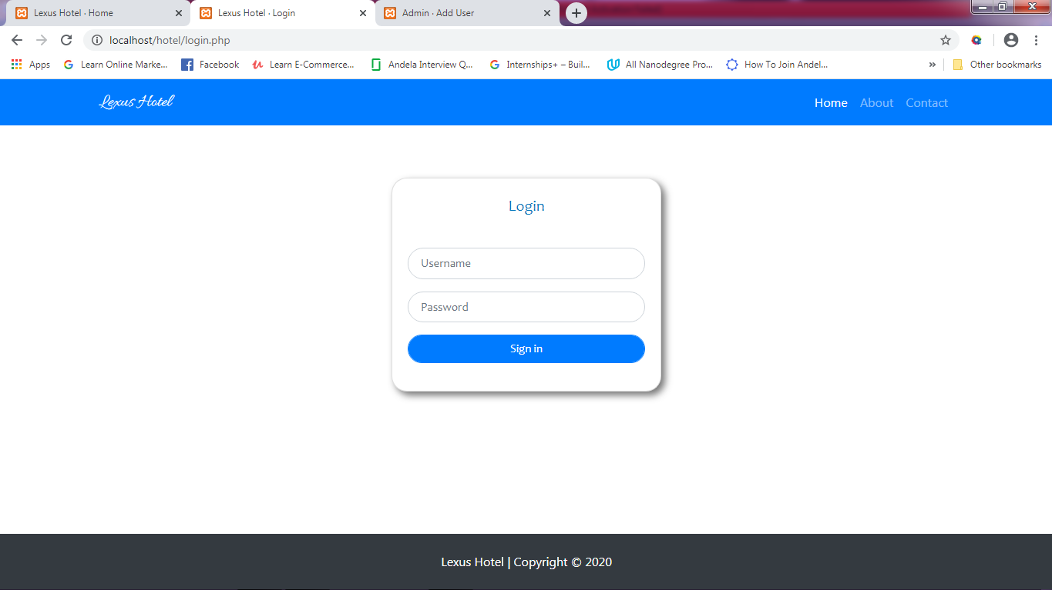

**Figure 3: System Login Page**

**4.2.2 Admin**

The administrative area gives a full view of the entire system. It consists of the following features:

* Dashboard: this dashboard holds information such as the total reservations, current reservations,
* Room Section: this section of the administrative area comprises two parts namely: Rooms and Reservations.

The “Rooms” sub section is made up of three dropdown bottoms which include view all rooms, add new rooms and add room features. The view all rooms gives a representation of all the rooms’ features by the hotel in a tabular manner. It also comprises of edit bottom to edit room information and a delete bottom to delete a room completely. The add new rooms allows the administrator to add a new room specifying the room type, room details, room image, room price, room status etc. the add room features enables the administrator to add additional room features especially images of the inner architecture of the room.

The “Reservations” sub section is made up of two dropdown bottoms which link to the all reservation and the current reservation pages respectively.

The All Reservations Page gives information on all the reservations that has ever been recorded and done on the system. It presents the following customer’s reservation information in a tabular manner: room type, reference ID, booking time, name, email, contact, check-in date, checkout date, nights spent, check-in time and the checkout time. The current reservation gives details on reservations in which the customers have not yet been checked in. It comprises of the following information in a tabular manner: room type, reference ID, booking time/date, email, check-in date, checkout date, nights spent, payment status check-in and checkout buttons.

* Users section: this section contains information on the amount of users (administrators) of the system. It comprises of two dropdown buttons which links to the view all users page and the add users page. The view all users page holds user information such as user_id, first name, last name, email, role and control buttons to either make user an admin, a subscriber, to edit user information or delete user completely.,

The add users page provides avenue of added users to the system. It contains forms with the following labels: first name, last name, email, password, and role.

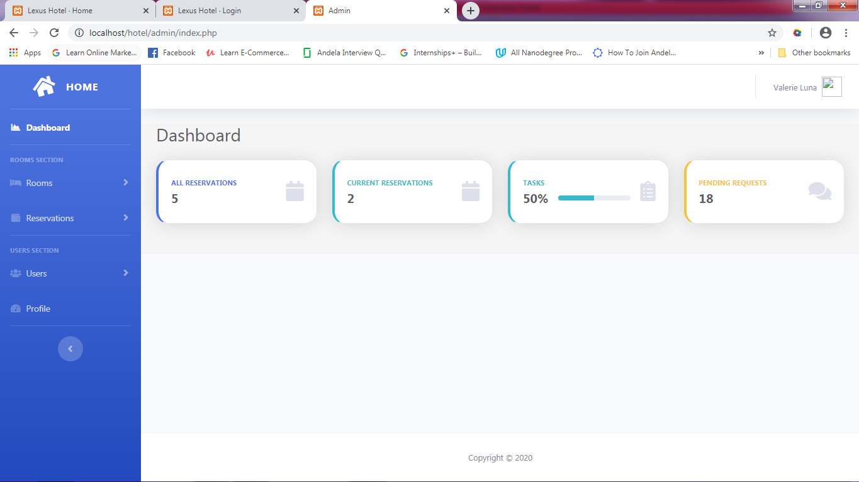

**CHAPTER FIVE**

**SUMMARY, CONCLUSION AND RECOMMENDATIONS**

**5.1 Summary**

Online hotel reservation

**5.2 Conclusion**

It is to this end that any business, as in our case, a hotel industry, that must scale in this 21st century and beyond must be available on the online resource. This grants the organization a competitive edge as it earns them a global access for 24 hours a day, 7 days a week, online services instead of been limited to the local environment where they could be found. It also improves client services through greater flexibility as clients can gain access to hotel rooms, make reservation with secured their payments from any part of the world as it also promotes increase in professionalism as it provides opportunity for the hotels to be managed from any part of the world.

Furthermore, being on the cloud affords various benefits for a hotel industry amongst which includes; security, as it is the responsibility of cloud service providers to carefully monitor security and update their facilities to foster this feature; scalability, this warrants the software to be scale up i.e. adding of extra computing resource such as automatically adding an extra CPU and scaling out e.g. adding more servers when the software may require it and in turn improves the speed and efficiency of the software etc.

In conclusion, this research work serves as a **pointer for any venture that seeks to grow rapidly and spread wider in this rapidly changing technological age to embrace online resource especially cloud technology as it hold enormous benefits for any venture which desires to scale globally.

**5.3 Recommendation**

This research work has achieved its aim and also serves as a reference point to the develop

Therefore, this research work strongly recommends that for any business to scale in this 21st century it must give adequate priority to online presence and availability as this exposes its chances

Also the advent of cloud technology and the advantages it offers cannot be overemphasized, hence in this ever growing digital age it in prominent for organizations to leverage the benefits that the cloud proffers.

**References**

Franco, C. E. & Bulomine, R. S. (2016). Advantages and Challenges of E-commerce Customers and Businesses: in Indian perspective. *International Journal of Research – Granthaalayah* , 4(3)

Glenda, A. D. & Mischelle, A. E. (2013). Online Hotel Reservation and Management System for the College of International Tourism and Hospitality Management. *International Journal of Computers & Technology*, *10*(1), 1202

Richard B., Akwasi A. & Emmanuel D. (2014). Online Hotel Reservation System. *IJISET - International Journal of Innovative Science, Engineering & Technology,* *1*(9), 1

Rocha, L. & Vazquez, A. (2014). Benefits of Adoption of Cloud Computing in Mexico *ECORFAN Journal, 5*(12), 2046

Shrikant, D. B. (2014). Cloud Migration Benefits and Its Challenges Issue. *IOSR Journal of Computer Engineering*

Marco Polo (2013). Online Hotel Reservation (OHRS).

Kendall, K. E. & Kendall, J. E. (2010). *Systems Analysis and Design* (10th ed.). Pearson

All these problems and more would definitely make a hotel experience a down time in business. But imploring an online hotel reservation system, the above mentioned problems are curbed, better user performance and availability of the system at all times is guaranteed (Richard, Akwasi & Emmanuel, 2014).